**1.INTRODUCTION**

A **comic book convention** or **comic-con** is an event with a primary focus on [comic books](https://en.wikipedia.org/wiki/Comic_books) and comic book culture, in which comic book [fans](https://en.wikipedia.org/wiki/Fan_(person)) gather to meet creators, experts, and each other. Commonly, comic conventions are multi-day events hosted at convention centers, hotels, or college campuses. They feature a wide variety of activities and panels, with a larger number of attendees participating in [cosplay](https://en.wikipedia.org/wiki/Cosplay) than most other types of [fan conventions](https://en.wikipedia.org/wiki/Fan_convention). Comic book conventions are also used as a vehicle for industry, in which publishers, distributors, and retailers represent their comic-related releases. Comic book conventions may be considered derivatives of [science-fiction conventions](https://en.wikipedia.org/wiki/Science-fiction_convention), which began in the late 1930s.

Comic-cons were traditionally organized by fans on a not-for-profit basis,[[1]](https://en.wikipedia.org/wiki/Comic_book_convention#cite_note-Siegel-1) though nowadays most events catering *to* fans are run by commercial interests for profit. Many conventions have award presentations relating to comics (such as the [Eisner Awards](https://en.wikipedia.org/wiki/Eisner_Award), which have been presented at [San Diego Comic-Con International](https://en.wikipedia.org/wiki/San_Diego_Comic-Con_International) since 1988; or the [Harvey Awards](https://en.wikipedia.org/wiki/Harvey_Awards), which have been presented at a variety of venues also since 1988).

At commercial events, comic book creators often give out autographs to the fans, sometimes in exchange for a flat appearance fee, and sometimes may draw illustrations for a per-item fee. Commercial conventions are usually quite expensive and are hosted in hotels. This represents a change in comic book conventions, which traditionally were more oriented toward comic books as a mode of literature, and maintained a less caste-like differentiation between professional and fan.

The first official comic book convention was held in 1964 in New York City and was called New York Comicon.Early conventions were small affairs, usually organized by local enthusiasts (such as [Jerry Bails](https://en.wikipedia.org/wiki/Jerry_Bails)**,** later known as the "Father of Comic Fandom", and Dave Kaler of the [Academy of Comic-Book Fans and Collectors](https://en.wikipedia.org/wiki/Academy_of_Comic-Book_Fans_and_Collectors)), and featuring a handful of industry guests. The first recurring conventions were the [Detroit Triple Fan Fair](https://en.wikipedia.org/wiki/Detroit_Triple_Fan_Fair), which ran from 1965–1978, and [Academy Con](https://en.wikipedia.org/wiki/Academy_Con), which ran from 1965–1967. Many recurring conventions begin as single-day events in small venues, which as they grow more popular expand to two days, or even three or more every year. Many comic-cons which had their start in church basements or union halls now fill [convention centers](https://en.wikipedia.org/wiki/Convention_center) in major cities.

**2. SOFTWARE AND HARDWARE REQUIREMENTS**

1. **SOFTWARE REQUIREMENTS:**

• OPERATING SYSTEM: Windows

• FRONT END: HTML, CSS

• SCRIPTS: JavaScript

• SOFTWARE APLLICATIONS: Text editor, Web Browser

1. **HARDWARE REQUIREMENTS**

• PROCESSOR: Intel i3/i5/i7

• RAM: 4GB/8GB/16GB

• HDD: 1TB/512GB/512SSD

**3. MODULE DESCRIPTION**

Comic-Con has presented literally thousands of special guests at its conventions over the years, bringing comics creators, science fiction and fantasy authors film and television directors, producers, and writers, and creators from all aspects of the popular arts together with their fans for a fun and often times candid discussion of various art forms. The event has seen an amazing array of comics and book publishers in its Exhibit Hall over the years. Over its four-and-a-half decade-plus history, Comic-Con International has continually presented comic books and comic art to a growing audience. That love of the comics medium continues to be its guiding factor as the event moves toward its second half-century as the premier comic book and popular arts style convention in the world.

**4. TECHNOLOGIES USED**

**HTML, CSS**

HTML stands for Hyper Text Markup Language. It is used to design web pages using a markup language. HTML is the combination of Hypertext and Markup language. Hypertext defines the link between web pages. A markup language is used to define the text document within the tag which defines the structure of web pages. This language is used to annotate (make notes for the computer) text so that a machine can understand it and manipulate text accordingly. Most markup languages (e.g., HTML) are human-readable. The language uses tags to define what manipulation has to be done on the text.

HTML is a markup language used by the browser to manipulate text, images, and other content, in order to display it in the required format. HTML was created by Tim Berners-Lee in 1991. The first-ever version of HTML was HTML 1.0, but the first standard version was HTML 2.0, published in 1995.

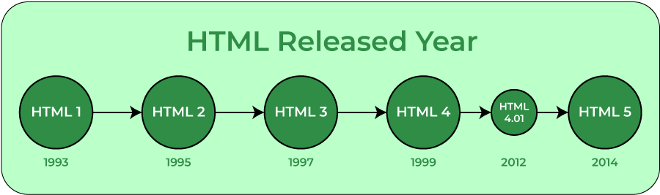

**Elements and Tags:** HTML uses predefined tags and elements which tell the browser how to properly display the content. Remember to include closing tags. If omitted, the browser applies the effect of the opening tag until the end of the page.

**HTML page structure:**The basic structure of an HTML page is laid out below. It contains the essential building-block elements (i.e., doctype declaration, HTML, head, title, and body elements) upon which all web pages are created.

**<html>:** This is called the HTML root element. All other elements are contained within it.

**<head>:** The head tag contains the “behind the scenes” elements for a webpage.

Elements within the head aren’t visible on the front-end of a webpage. HTML elements used inside the <head> element include:

* <style>-This html tag allows us to insert styling into our webpages and make them appealing to look at with the help of CSS.
* <title>-The title is what is displayed on the top of your browser when you visit a website and contains title of the webpage that you are viewing.
* <base>-It specifies the base URL for all relative URLs in a document.
* <noscript>– Defines a section of HTML that is inserted when the scripting has been turned off in the user’s browser.
* <script>-This tag is used to add functionality in the website with the help of JavaScript.
* <meta>-This tag encloses the meta data of the website that must be loaded every time the website is visited. For e.g.: - the metadata charset allows you to use the standard UTF-8 encoding in your website. This in turn allows the users to view your webpage in the language of their choice. It is a self-closing tag.
* <link>– The ‘link’ tag is used to tie together HTML, CSS and JavaScript. It is self-closing.

**<body>:** The body tag is used to enclose all the visible content of a webpage. In other words, the body content is what the browser will show on the front-end.

An HTML document can be created using any text editor. Save the text file using **.html** or **.htm**. Once saved as an HTML document, the file can be opened as a webpage in the browser.

**Features of HTML:**

* It is easy to learn and easy to use.
* It is platform-independent.
* Images, videos, and audio can be added to a web page.
* Hypertext can be added to the text.
* It is a markup language.

**Why learn HTML?**

* It is a simple markup language. Its implementation is easy.
* It is used to create a website.
* Helps in developing fundamentals about web programming.
* Boost professional career.

**Advantages:**

* HTML is used to build websites.
* It is supported by all browsers.
* It can be integrated with other languages like CSS, JavaScript, etc.

**Disadvantages:**

* HTML can only create static web pages. For dynamic web pages, other languages have to be used.
* A large amount of code has to be written to create a simple web page.
* The security feature is not good.

**C**ascading **S**tyle **S**heets, fondly referred to as **CSS**, is a simply designed language intended to simplify the process of making web pages presentable. CSS allows you to apply styles to web pages. More importantly, CSS enables you to do this independent of the HTML that makes up each web page. It describes how a webpage should look: it prescribes colors, fonts, spacing, and much more. In short, you can make your website look however you want. CSS lets developers and designers define how it behaves, including how elements are positioned in the browser.

While html uses tags, css uses rulesets. CSS is easy to learn and understand, but it provides powerful control over the presentation of an HTML document.

**Why CSS?**

* **CSS saves time:**You can write CSS once and reuse the same sheet in multiple HTML pages.
* **Easy Maintenance:**To make a global change simply change the style, and all elements in all the webpages will be updated automatically.
* **Search Engines:**CSS is considered a clean coding technique, which means search engines won’t have to struggle to “read” its content.
* **Superior styles to HTML:**CSS has a much wider array of attributes than HTML, so you can give a far better look to your HTML page in comparison to HTML attributes.
* **Offline Browsing:**CSS can store web applications locally with the help of an offline cache. Using this we can view offline websites.

CSS versions release years:

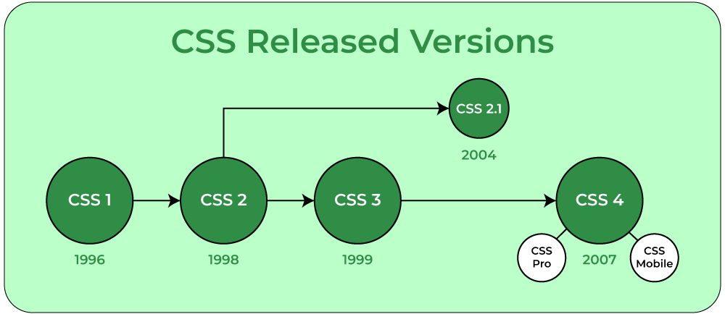

**CSS Syntax:**

CSS comprises style rules that are interpreted by the browser and then applied to the corresponding elements in your document.  
A style rule set consists of a selector and declaration block.

**Selector -- h1**

**Declaration -- {color:blue;font size:12px;}**

* The selector points to the HTML element you want to style.
* The declaration block contains one or more declarations separated by semicolons.
* Each declaration includes a CSS property name and a value, separated by a colon.

For Example:

color is property and blue is value.  
font-size is property and 12px is value.

* CSS declaration always ends with a semicolon, and declaration blocks are surrounded by curly braces.

**CSS Selectors:** CSS selectors are used to “find” (or select) HTML elements based on their element name, id, class, attribute, and more.

**1.** **UNIVERSAL SELECTORS:**Rather than selecting elements of a specific type, the universal selector quite simply matches the name of any element type.

**2.ELEMENT SELECTORS:**The element selector selects elements based on the element name. You can select all p elements on a page like this (in this case, all p elements will be center-aligned, with a red text color).

**3.DESCENDANT SELECTORS:**Suppose you want to apply a style rule to a particular element only when it lies inside a particular element. As given in the following example, the style rule will apply to the em element only when it lies inside the ul tag.

**4.ID SELECTORS:**

* The id selector uses the id attribute of an HTML element to select a specific element.
* The id of an element should be unique within a page, so the id selector is used to select one unique element!
* To select an element with a specific id, write a hash (#) character, followed by the id of the element.
* The style rule below will be applied to the HTML element with id=”para1″:

**5.CLASS SELECTORS:**

* The class selector selects elements with a specific class attribute.
* To select elements with a specific class, write a period (.) character, followed by the name of the class.
* In the example below, all HTML elements with class = ”center” will be green and center-aligned:

**5. IMPLEMENTATION**

**HOME PAGE:**

<!DOCTYPE html>

<html lang="en" dir="ltr">

<head>

<meta charset="utf-8">

<title>Responsive Navigation Menu</title>

<link rel="stylesheet" href="styl.css">

<link rel="stylesheet" href="slider.js">

<meta charset="UTF-8">

<meta http-equiv="X-UA-Compatible" content="IE=edge">

<meta name="viewport" content="width=device-width, initial-scale=1.0">

<link rel="stylesheet" href="https://cdnjs.cloudflare.com/ajax/libs/font-awesome/5.15.3/css/all.min.css"/>

<meta name="viewport" content="width=device-width, initial-scale=1.0">

</head>

<body>

<nav>

<div class="logo">

Comic-ConX

</div>

<input type="checkbox" id="click">

<label for="click" class="menu-btn">

<i class="fas fa-bars"></i>

</label>

<ul>

<li><a class="fj.html" href="#">Home</a></li>

<li><a href="about.html">About</a></li>

<li><a href="#c1" class="navlink1">Buy passes</a></li>

<li><a href="gallery.html"> Gallery</a></li>

<li><a href="feedback.html">Feedback</a></li>

<ul>

<li>

</li>

</ul>

</nav>

<img src="comic.jpg" width="1260" height="600">

<center><h1>INDIA'S GREATEST</h1>

<h1>POP CULTURE<h1>

<div class="box-container">

<div class="box">

<img src="img10.jpg" alt="">

<div class="content">

<p>Best of comic books & coolest creators...signed and delivered!</p>

</div>

</div>

<div class="box">

<img src="img11.jpg" alt="">

<div class="content">

<p>Cosplay your heart out and see some of the best cosplayers in the world</p>

</div>

</div>

<div class="box">

<img src="img12.jpg" alt="">

<div class="content">

<p>The best live experiences from the likes of Marvel, DC, WWE to many more.</p>

</div>

</div>

<div class="box">

<img src="img13.jpg" alt="">

<div class="content">

<p>Start your collections with the

coolest merch in India</p>

</div>

</div>

<div class="box">

<img src="img14.jpg" alt="">

<div class="content">

<p>From celebrities to comic bookcreators, we got 'em all</p>

</div>

</div>

<div class="box">

<img src="img15.jpg" alt="">

<div class="content">

<p>Esports to table-top gaming,it's all here</p>

</div>

</div>

</div>

<div class="hyper">

<iframe width="800" height="500" src="https://www.youtube.com/embed/kGcQzh3XksM" title="YouTube video player" frameborder="0" allow="accelerometer; autoplay; clipboard-write; encrypted-media; gyroscope; picture-in-picture; web-share" allowfullscreen></iframe>

</div>

<img src="scrn1.jpg" width="1260" height="600">

<div class="container2" id="c1">

<h1 class="heading2">buy passess</h1>

<div class="box-container2">

<div class="box2">

<h3>BENGALURU</h3>

<p>Greatest comic cosplay place in india ,now it is happening near you </p>

<a class="btn">BOOK NOW</a>

</div>

<div class="box2">

<h3>DELHI</h3>

<p>Greatest comic cosplay place in india ,now it is happening near you </p>

<a class="btn">BOOK NOW</a>

</div>

<div class="box2">

<h3>MUMBAI</h3>

<p>>Greatest comic cosplay place in india ,now it is happening near you </p>

<a class="btn">BOOK NOW</a>

</div>

</div>

</div>

</body>

</html>

**CSS FILE:**

@import url('https://fonts.googleapis.com/css?family=Poppins:400,500,600,700&display=swap');

*{

margin: 0;

padding: 0;

box-sizing: border-box;

font-family: 'Poppins', sans-serif;

}

nav{

display: flex;

height: 80px;

width: 100%;

background: #1b1b1b;

align-items: center;

justify-content: space-between;

padding: 0 50px 0 100px;

flex-wrap: wrap;

}

nav .logo{

color: #fff;

font-size: 35px;

font-weight: 600;

}

nav ul{

display: flex;

flex-wrap: wrap;

list-style: none;

}

nav ul li{

margin: 0 5px;

}

nav ul li a{

color: #f2f2f2;

text-decoration: none;

font-size: 18px;

font-weight: 500;

padding: 8px 15px;

border-radius: 5px;

letter-spacing: 1px;

transition: all 0.3s ease;

}

nav ul li a:hover{

color: #111;

background: #fff;

}

nav .menu-btn i{

color: #fff;

font-size: 22px;

cursor: pointer;

display: none;

}

input[type="checkbox"]{

display: none;

}

@media (max-width: 1000px){

nav{

padding: 0 40px 0 50px;

}

}

@media (max-width: 920px) {

nav .menu-btn i{

display: block;

}

#click:checked ~ .menu-btn i:before{

content: "\f00d";

}

nav ul{

position: fixed;

top: 80px;

left: -100%;

background: #111;

height: 100vh;

width: 100%;

text-align: center;

display: block;

transition: all 0.3s ease;

}

#click:checked ~ ul{

left: 0;

}

nav ul li{

width: 100%;

margin: 40px 0;

}

nav ul li a{

width: 100%;

margin-left: -100%;

display: block;

font-size: 20px;

transition: 0.6s cubic-bezier(0.68, -0.55, 0.265, 1.55);

}

#click:checked ~ ul li a{

margin-left: 0px;

}

nav ul li a.active,

nav ul li a:hover{

background: none;

color: cyan;

}

}

.packages .box-container{

display: grid;

grid-template-columns: auto auto auto;

background-color: #2196F3;

padding: 10px;

}

.packages .box-container .box{

flex:1 1 30rem;

border-radius: .5rem;

overflow: hidden;

box-shadow: 0 1rem 2rem rgba(0,0,0,.1);

}

.packages .box-container .box img{

height: 25rem;

width:100%;

object-fit: cover;

}

.packages .box-container .box .content{

padding:2rem;

}

.hyper

{

background-image: url("black\ img.jpg");

}

*{

font-family: 'Poppins', sans-serif;

margin:0; padding:0;

box-sizing: border-box;

outline: none; border:none;

text-decoration: none;

text-transform: capitalize;

transition: .2s linear;

}

.container2{

background:linear-gradient(45deg, rgb(35, 35, 35), rgb(10, 10, 10));

padding:15px 9%;

padding-bottom: 100px;

}

.container2 .heading2{

text-align: center;

padding-bottom: 15px;

color:#fff;

text-shadow: 0 5px 10px rgba(0,0,0,.2);

font-size: 50px;

}

.container2 .box-container2{

display: grid;

grid-template-columns: repeat(auto-fit, minmax(270px, 1fr));

gap:15px;

}

.container2 .box-container2 .box2{

box-shadow: 0 5px 10px rgba(0,0,0,.2);

border-radius: 5px;

background: #fff;

text-align: center;

padding:30px 20px;

}

.container2 .box-container2 .box2 h3{

color:#444;

font-size: 22px;

padding:10px 0;

}

.container2 .box-container2 .box2 p{

color:#777;

font-size: 15px;

line-height: 1.8;

}

.container2 .box-container2 .box2 .btn{

margin-top: 10px;

display: inline-block;

background:#333;

color:#fff;

font-size: 17px;

border-radius: 5px;

padding: 8px 25px;

}

.container2 .box-container2 .box2 .btn:hover{

letter-spacing: 1px;

}

.container2 .box-container2 .box2:hover{

box-shadow: 0 10px 15px rgba(0,0,0,.3);

transform: scale(1.03);

}

@media (max-width:768px){

.container2{

padding:20px;

}

}

.about

{

background-image: url(black\ img.jpg);

}

.about li

{

list-style-type:none;

left: 15%;

padding-left: 10px;

justify-content: space-around;

display:inline-block;

margin:0 5px;

position:relative;

}

.about h1

{

color:yellow;

}

.about h2

{

color:yellow;

}

.about p

{

color:white

}

.rule

{

background-image: url(black\ img.jpg);

}

body{

margin: 0;

font-family: sans-serif;

}

.section{

background-color: #252121;

display: flex;

justify-content: space-between;

padding: 40px;

width: 60%;

background-position-x: 70% ;

}

.section img{

height: 250px;

}

.section h1{

margin: 0;

color: aquamarine;

}

.section p{

color: aliceblue;

margin-right: 15px;

}

*{

margin: 0;

padding: 0;

box-sizing: border-box;

font-family: 'Poppins', sans-serif;

}

.container1{

display: flex;

flex-direction: column;

justify-content: center;

align-items: center;

text-align: center;

margin: 40px 20px 0 20px;

}

.container1 .heading1{

width: 50%;

padding-bottom: 50px;

}

.container1 .heading1 h3{

font-size: 3em;

font-weight: bolder;

padding-bottom: 10px;

border-bottom: 3px solid #222;

}

.container1 .heading1 h3 span{

font-weight: 100;

}

.container1 .box{

display: flex;

flex-direction: row;

justify-content: space-between;

}

.container1 .box .dream{

display: flex;

flex-direction: column;

width: 32.5%;

}

.container1 .box .dream img{

width: 100%;

padding-bottom: 15px;

border-radius: 5px;

}

.container1 .btn{

margin: 40px 0 70px 0;

background: #222;

padding: 15px 40px ;

border-radius: 5px;

}

.container1 .btn a{

color: #fff;

font-size: 1.2em;

text-decoration: none;

font-weight: bolder;

letter-spacing: 3px;

}

@media only screen and (max-width: 769px){

.container1 .box{

flex-direction: column;

}

.container1 .box .dream{

width: 100%;

}

}

@media only screen and (max-width: 643px){

.container1 .heading1{

width: 100%;

}

.container1 .heading1 h3{

font-size: 1em;

}

}

*, *:before, *:after {

box-sizing: border-box;

-webkit-font-smoothing: antialiased;

-moz-osx-font-smoothing: grayscale;

}

body {

background: linear-gradient(to right, #ea1d6f 0%, #FFFF00 100%);

font-size: 12px;

}

body, button, input {

font-family: 'Montserrat', sans-serif;

font-weight: 700;

letter-spacing: 1.4px;

}

.background {

display: flex;

min-height: 100vh;

}

.container {

flex: 0 1 700px;

margin: auto;

padding: 10px;

}

.screen {

position: relative;

background: #3e3e3e;

border-radius: 15px;

}

.screen:after {

content: '';

display: block;

position: absolute;

top: 0;

left: 20px;

right: 20px;

bottom: 0;

border-radius: 15px;

box-shadow: 0 20px 40px rgba(0, 0, 0, .4);

z-index: -1;

}

.screen-header {

display: flex;

align-items: center;

padding: 10px 20px;

background: #4d4d4f;

border-top-left-radius: 15px;

border-top-right-radius: 15px;

}

.screen-header-left {

margin-right: auto;

}

.screen-header-button {

display: inline-block;

width: 8px;

height: 8px;

margin-right: 3px;

border-radius: 8px;

background: white;

}

.screen-header-button.close {

background: #ed1c6f;

}

.screen-header-button.maximize {

background: #e8e925;

}

.screen-header-button.minimize {

background: #74c54f;

}

.screen-header-right {

display: flex;

}

.screen-header-ellipsis {

width: 3px;

height: 3px;

margin-left: 2px;

border-radius: 8px;

background: #999;

}

.screen-body {

display: flex;

}

.screen-body-item {

flex: 1;

padding: 50px;

}

.screen-body-item.left {

display: flex;

flex-direction: column;

}

.app-title {

display: flex;

flex-direction: column;

position: relative;

color: #ea1d6f;

font-size: 26px;

}

.app-title:after {

content: '';

display: block;

position: absolute;

left: 0;

bottom: -10px;

width: 25px;

height: 4px;

background: #ea1d6f;

}

.app-contact {

margin-top: auto;

font-size: 8px;

color: #888;

}

.app-form-group {

margin-bottom: 15px;

}

.app-form-group.message {

margin-top: 40px;

}

.app-form-group.buttons {

margin-bottom: 0;

text-align: right;

}

.app-form-control {

width: 100%;

padding: 10px 0;

background: none;

border: none;

border-bottom: 1px solid #666;

color: #ddd;

font-size: 14px;

text-transform: uppercase;

outline: none;

transition: border-color .2s;

}

.app-form-control::placeholder {

color: #666;

}

.app-form-control:focus {

border-bottom-color: #ddd;

}

.app-form-button {

background: none;

border: none;

color: #ea1d6f;

font-size: 14px;

cursor: pointer;

outline: none;

}

.app-form-button:hover {

color: #b9134f;

}

.credits {

display: flex;

justify-content: center;

align-items: center;

margin-top: 20px;

color: #ffa4bd;

font-family: 'Roboto Condensed', sans-serif;

font-size: 16px;

font-weight: normal;

}

.credits-link {

display: flex;

align-items: center;

color: #fff;

font-weight: bold;

text-decoration: none;

}

.dribbble {

width: 20px;

height: 20px;

margin: 0 5px;

}

@media screen and (max-width: 520px) {

.screen-body {

flex-direction: column;

}

.screen-body-item.left {

margin-bottom: 30px;

}

.app-title {

flex-direction: row;

}

.app-title span {

margin-right: 12px;

}

.app-title:after {

display: none;

}

}

@media screen and (max-width: 600px) {

.screen-body {

padding: 40px;

}

.screen-body-item {

padding: 0;

}

}

**ABOUT US PAGE:**

<html>

<head>

<title>tryfyt</title>

<link rel="stylesheet" href="styl.css">

</head>

<body>

<nav>

<div class="logo">

Comic-ConX

</div>

<input type="checkbox" id="click">

<label for="click" class="menu-btn">

<i class="fas fa-bars"></i>

</label>

<ul>

<li><a class="active" href="fj.html">Home</a></li>

<li><a href="about.html">About</a></li>

<li><a href="gallery.html"> Gallery</a></li>

<li><a href="feedback.html">Feedback</a></li>

<ul>

<li>

</li>

</ul>

</nav>

<video width="1260" height="600" controls>

<source src="pj.mp4">

</video>

<div class="about">

<br><br>

<h1 align="center"> JUDGING</h1><br>

<li><h2>Craftsmanship</h2><br><br><p>How the entrant made their costume,<br>use ofmaterials and creativity</p></li>

<li><h2>Likeness/Detail</h2><br><br><p>How close the contestant resembles<br>the character they are cosplaying /<br>detail on costum</p></li>

<li><h2>Presentation</h2><br><br><p>How the entrant portrays themselves as<br>the character they are cosplaying</p></li>

<br><br><br>

</div>

<div class="rules" align="center">

<h1> RULES</h1>

<p>

All entrants must be 16 or older to compete. And must have a valid PAN Card in order to qualify to win the Grand Prize.<br><br>

All selected contestants are responsible for all expenses related to competing in the BCC Cosplay Contest including all lodging and travel to and from the convention center. All contestants must have valid BCC Ticket & Wristband for the day of the contest.<br><br>

A contestant may participate in the BCC Cosplay Contest only once each day. Applicants may not register multiple times with multiple costumes. A contestant can only enter once and only wear one costume each day<br>

Group costumes are not allowed as part of the contest. However maybe allowed on stage during cosplay parade.<br><br>

No electrical power connections will be provided. If your costume requires power, it must be part of your costume design.<br><br>

Contestants are responsible for their own belongings. We are unable to provide a secure area for personal items. We recommend bringing an assistant to help with belongings.<br><br>

No nudity. All costumes should provide enough coverage to be worn in public and should be in good taste and appropriate for a family-friendly show. Gore, graphic violence, or other objectionable elements may be grounds for disqualification as determined by the judges or Comic Con India (CCI) Staff.<br><br>

Costume cannot communicate messages or images inconsistent with the positive images and/or goodwill to which CCI wishes to associate with<br><br>

Costume cannot depict, and cannot itself, be in violation of any law.<br><br>

No profanity allowed on stage. That includes messages on signs or clothes. Anyone who violates this may be disqualified from the competition.<br><br>

No political or religious statements are allowed on stage or during judging. Anyone who violates this may be disqualified from the competition.<br><br>

Costumes cannot promote alcohol, illegal drugs, tobacco, firearms/weapons (or the use of any of the foregoing), any activities that may appear unsafe or dangerous, or any particular political agenda or message.<br><br>

Costumes cannot be obscene or offensive, endorse any form of hate or hate group.<br><br>

Costume cannot defame, misrepresent or contain disparaging remarks about CCI or its products, or other people, products or companies.<br><br>

Costume cannot communicate messages or images inconsistent with the positive images and/or goodwill to which CCI wishes to associate; and Costume cannot depict, and cannot itself, be in violation of any law.<br><br>

Please refrain from wearing or using any substances that may potentially interfere with another participant’s costume. If you are wearing body paint or make-up, please make sure it will not come in contact with others. Do not leave anything on stage that could damage the other costumes. Do not leave anything on stage at all.<br><br>

Your costume must allow movement with limited assistance. Your costume must not impede your ability to get on and off stage. Furthermore, your costume cannot be built on stage.<br><br>

All prop weapons must conform to the CCI Weapons Policy.<br><br>

The following items are forbidden at all CCI Shows & Partner events:· <br> <br>

Functional firearms (including air soft guns, BB guns, cap guns, paintball guns and pellet guns)<br>

Realistic replica firearms (including reproduction, fake or toy guns that can be confused for functional firearms)<br>

Functional projectile weapons (including blow guns, crossbows, long bows, silly string, slingshots, water balloons and water guns)<br>

Sharpened metal-bladed weapons (including axes, daggers, hatches, knives, kunai, shuriken, swords, sword canes and switch blades)· <br> <br>

Explosives(including firecrackers and fireworks)<br>

Chemical weapons (including mace and pepper spray)<br>

Blunt weapons (including brass knuckles, bats, clubs and nunchaku)<br>

Hard prop weapons (including props made of metal, fiberglass and glass)<br>

Instruments that cause excessive noise levels like vuvuzelas<br>

Prop weapons will be allowed providing they are composed of cardboard, foam or other light materials. Prop firearms are allowed only if they cannot be mistaken forreal weapons. The barrel of all prop firearms must be covered with brightly colored caps. Prop bows will be allowed providing all arrows have foam tips and cannot be used to harm anyone.<br><br>

Wings, large props, or large costumes are just fine, but if your costume is over 8 feet tall, or 4 feet wide you may not fit through the doors. If possible, make wings and other parts that make your costume detachable.<br><br>

We have no limit on the size of costumes or props, but ask that you be safe and aware while on stage. You will be responsible for ALL damage to the stage, lighting, technical aspects or any convention property.<br><br>

‍In case of any issue of harassment on the event premises, get in touch with CCI staff or a member of Security immediately. Comic Con India will not tolerate any sort of harassment of our attendees whether they are in costume or not. Check Out Our ANTI-HARASSMENT POLICY <br>

Receiving the prize is contingent upon compliance with these Official Rules.<br><br>

</p>

</div>

<div class="rule" align="center"><br><br>

<h1 style="color:white"> FOR THE LOVE<br>OF COSPLAY</h1><br>

<h5 style="color:white"> A Passion. An Expression. A Feeling. A movement.<br>

The love of cosplay brings the fandom together.<br>

</h5><br><br>

<iframe width="560" height="315" src="https://www.youtube.com/embed/AGEuQ3Q6Tm4" title="YouTube video player" frameborder="0" allow="accelerometer; autoplay; clipboard-write; encrypted-media; gyroscope; picture-in-picture; web-share" allowfullscreen></iframe>

<br><br><br></div>

</body>

</html>

**GALLERY PAGE:**

<html>

<head>

<meta name="viewport" content="width=device-width, initial-scale=1.0">

<link rel="stylesheet" href="gallery.css">

<link rel="stylesheet" href="styl.css">

<link rel="stylesheet" href="https://cdn.jsdelivr.net/npm/swiper@8/swiper-bundle.min.css"/>

</head>

<body>

<nav>

<div class="logo">

Comic-ConX

</div>

<input type="checkbox" id="click">

<label for="click" class="menu-btn">

<i class="fas fa-bars"></i>

</label>

<ul>

<li><a class="active" href="fj.html">Home</a></li>

<li><a href="about.html">About</a></li>

<li><a href="gallery.html"> Gallery</a></li>

<li><a href="feedback.html">Feedback</a></li>

<ul>

<li>

</li>

</ul>

</nav>

<div class="container">

<div class="swiper">

<!-- Additional required wrapper -->

<div class="swiper-wrapper">

<!-- Slides -->

<div class="swiper-slide"><img src="img0.jpg" width="1300" height="700"></div>

<div class="swiper-slide"><img src="img.jpg" width="1300" height="700"></div>

<div class="swiper-slide"><img src="img-1.jpg" width="1300" height="700"></div>

<div class="swiper-slide"><img src="img-2.jpg" width="1300" height="700"></div>

<div class="swiper-slide"><img src="img-3.jpg" width="1300" height="700"></div>

<div class="swiper-slide"><img src="img-4.jpg" width="1300" height="700"></div>

</div>

<!-- If we need pagination -->

<div class="swiper-pagination"></div>

<!-- If we need navigation buttons -->

<div class="swiper-button-prev"></div>

<div class="swiper-button-next"></div>

</div>

</div>

<script src="https://cdn.jsdelivr.net/npm/swiper@8/swiper-bundle.min.js"></script>

<script>

const swiper = new Swiper('.swiper', {

autoplay: {

delay: 1200,

disableOnInteraction: false,

},

loop: true,

pagination: {

el: '.swiper-pagination',

clickable: true,

},

navigation: {

nextEl: '.swiper-button-next',

prevEl: '.swiper-button-prev',

},

});

</script>

<div class="container1">

<div class="heading1">

<h3>Photo <span>Gallery</span></h3>

</div>

<div class="box">

<div class="dream">

<img src="1.jpg">

<img src="2.jpg">

<img src="3.jpg">

<img src="4.jpg">

<img src="5.jpg">

</div>

<div class="dream">

<img src="6.jpg">

<img src="7.jpg">

<img src="8.jpg">

<img src="9.jpg">

<img src="10.jpg">

</div>

<div class="dream">

<img src="11.jpg">

<img src="12.jpg">

<img src="13.jpg">

<img src="14.jpg">

<img src="15.jpg">

</div>

</div>

<div class="btn">

<a href="#">More</a>

</div>

</div>

</body>

</html>

**FEEDBACK PAGE:**

<html>

<head>

<link rel="stylesheet" href="feedback.css">

<link rel="stylesheet" href="styl.css">

<body>

<nav>

<div class="logo">

Comic-ConX

</div>

<input type="checkbox" id="click">

<label for="click" class="menu-btn">

<i class="fas fa-bars"></i>

</label>

<ul>

<li><a class="active" href="fj.html">Home</a></li>

<li><a href="about.html">About</a></li>

<li><a href="gallery.html"> Gallery</a></li>

<li><a href="feedback.html">Feedback</a></li>

<ul>

<li>

</li>

</ul>

</nav>

<div class="background">

<div class="container">

<div class="screen">

<div class="screen-header">

<div class="screen-header-left">

<div class="screen-header-button close"></div>

<div class="screen-header-button maximize"></div>

<div class="screen-header-button minimize"></div>

</div>

<div class="screen-header-right">

<div class="screen-header-ellipsis"></div>

<div class="screen-header-ellipsis"></div>

<div class="screen-header-ellipsis"></div>

</div>

</div>

<div class="screen-body">

<div class="screen-body-item left">

<div class="app-title">

<span>CONTACT</span>

<span>INDIA</span>

</div>

<div class="app-contact">CONTACT INFO : +91 81 314 928 595</div>

</div>

<div class="screen-body-item">

<div class="app-form">

<div class="app-form-group">

<input class="app-form-control" placeholder="NAME">

</div>

<div class="app-form-group">

<input class="app-form-control" placeholder="EMAIL">

</div>

<div class="app-form-group">

<input class="app-form-control" placeholder="CONTACT NO">

</div>

<div class="app-form-group message">

<input class="app-form-control" placeholder="MESSAGE">

</div>

<div class="app-form-group buttons">

<button class="app-form-button">CANCEL</button>

<button class="app-form-button">SEND</button>

</div>

</div>

</div>

</div>

</div>

</div>

</div>

</body>

</head>

</html>

**6. SCREEN SHOTS**

**HOME PAGE**

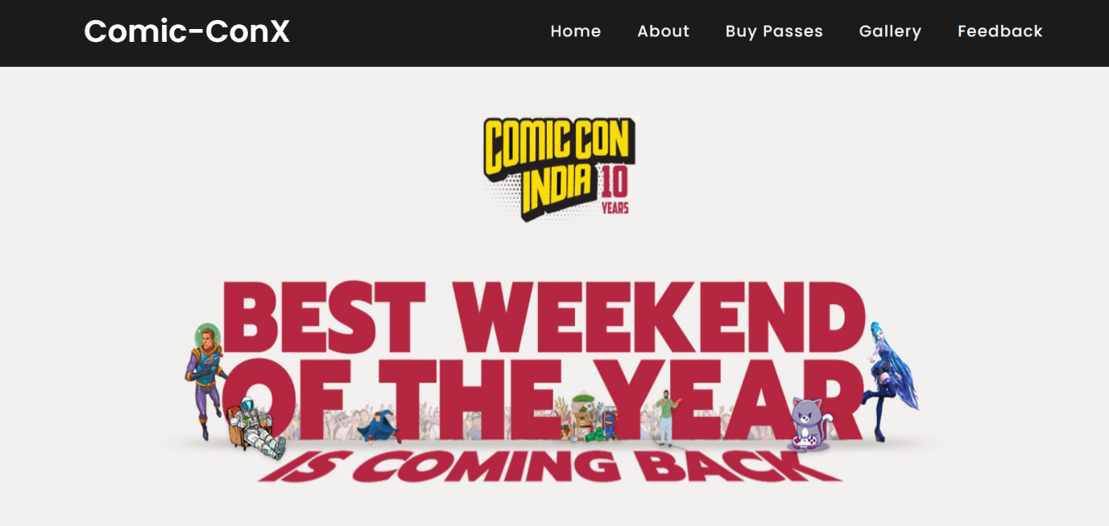

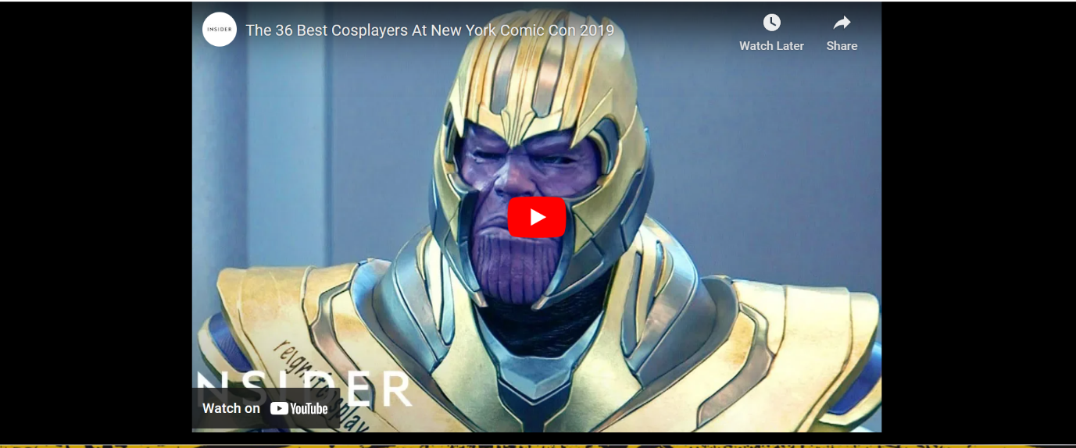

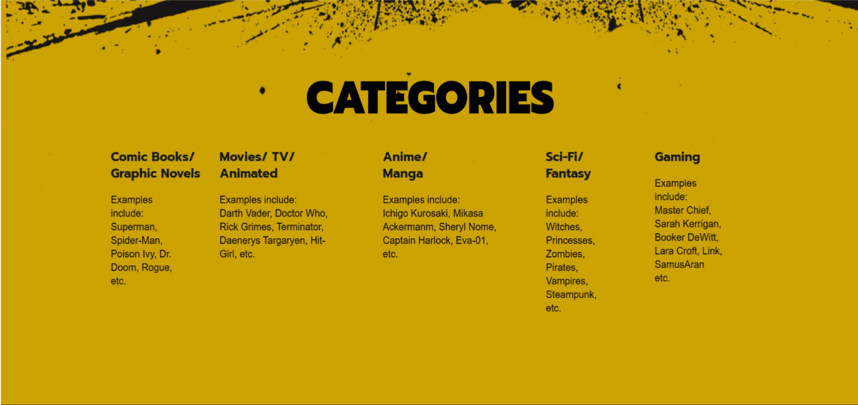



**ABOUT US PAGE**

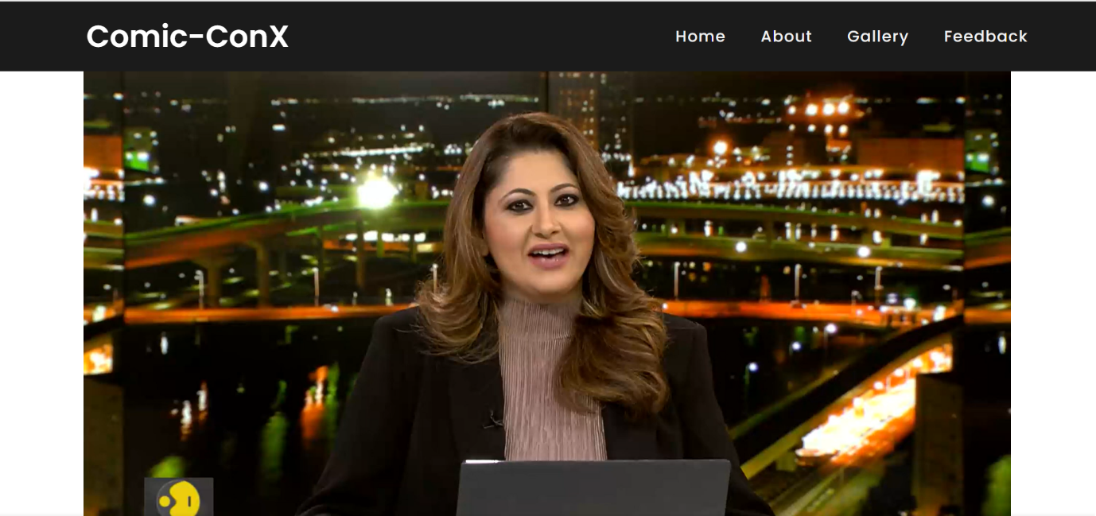

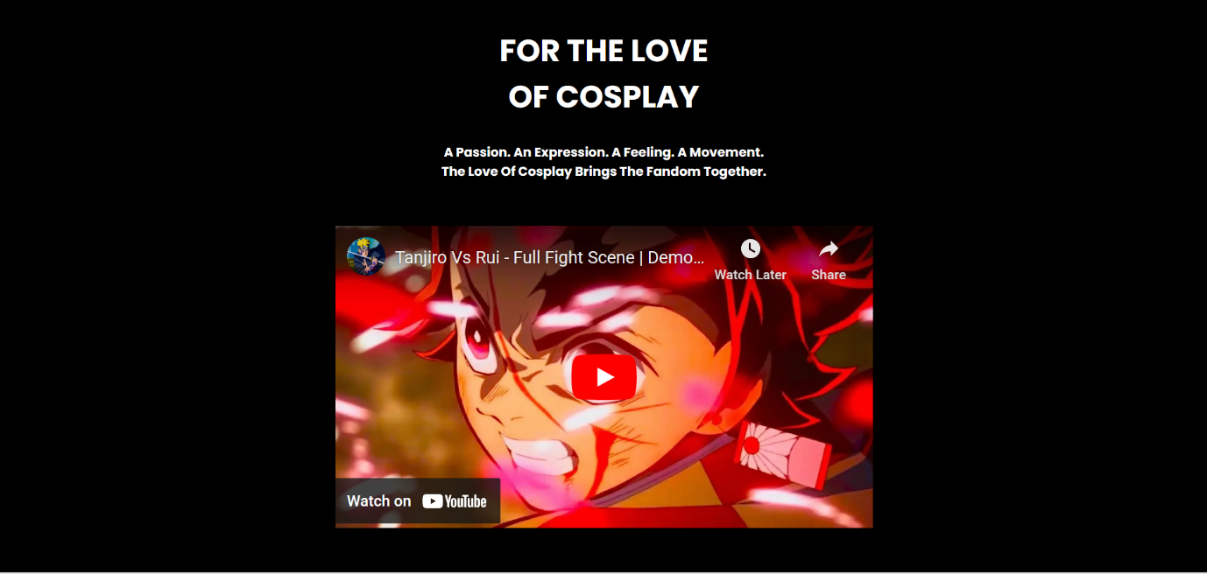

**GALLERY PAGE**

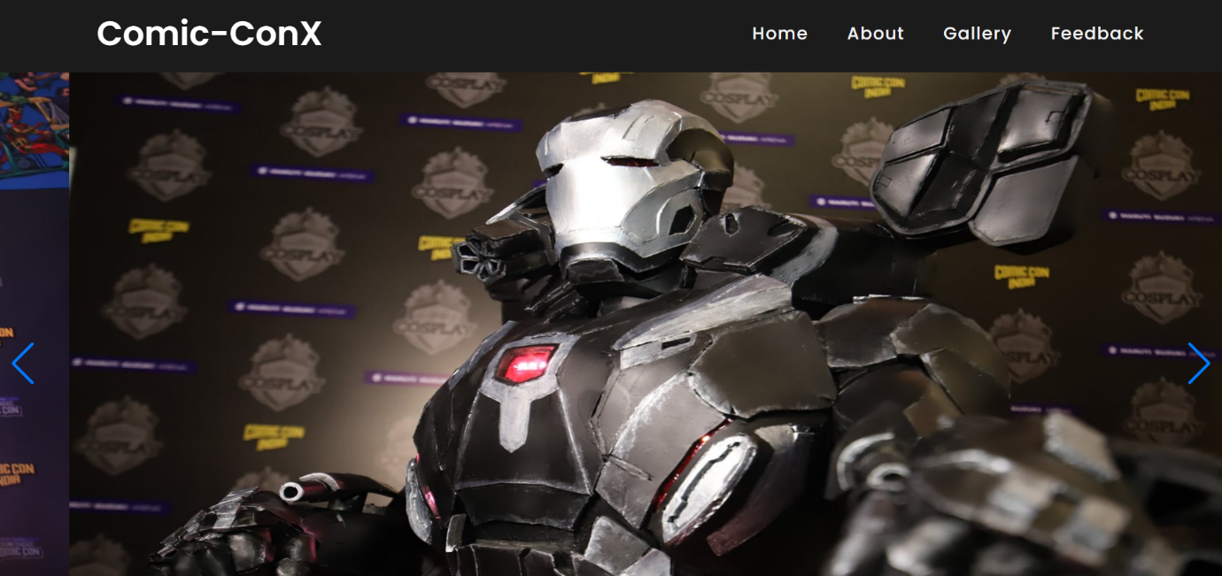

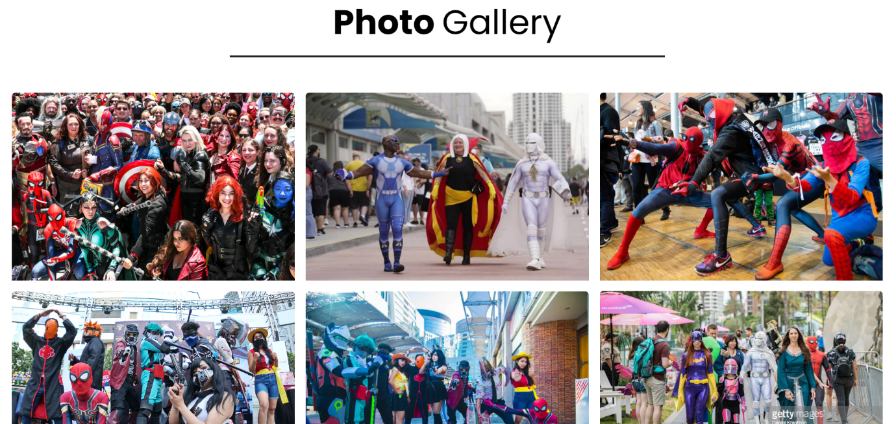

**FEEDBACK PAGE**

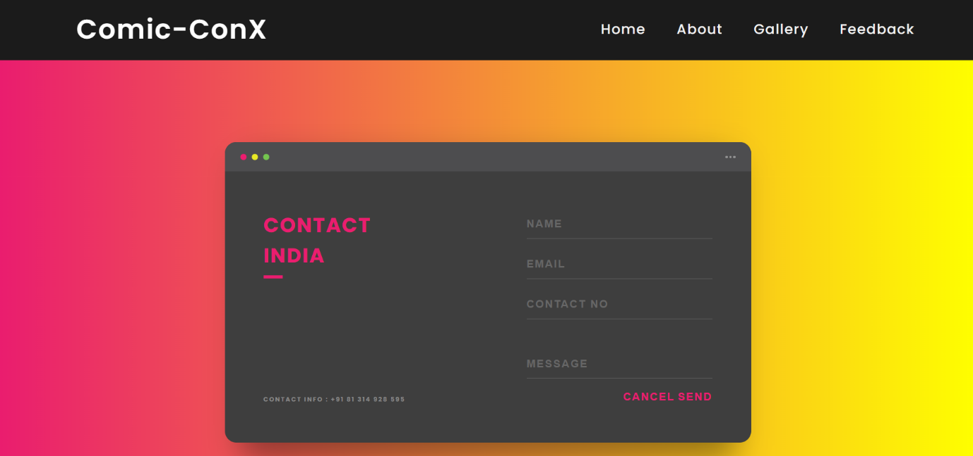

**7. CONCLUSION**

Through this hands-on project I was able to see how well I understood the material presented, and my critical thinking as I developed the COMIC-CON website. I was also able to show my creative side, through the layout and design of my project. Knowing basic HTML, CSS AND JAVASCRIPT is a skill that will help you with blogging, working with Wiki's, Facebook, and much more. Moreover while developing my website, I learned a lot about HTML tags & elements and CSS attributes. This enhanced my knowledge regarding the web portal development. Thus, in future if I do any kind of web based projects this project experience will be more helpful.

**8. REFERENCES**

References I used in the project:

• Right star events website

• W3 schools website

• Externals Sources

**Right star official website:** [**http://www.comicConIndia.com/**](http://www.comicConIndia.com/)

**W3 schools official website:** [**https://www.w3schools.com/**](https://www.w3schools.com/)

From this I used the theme for my website, the collection I placed on the website was collected from here. I used so many things from here like the character names, costume names.

**External Sources:** I used HTML tags and CSS attributes from external sources and used them to develop my website.

1. <https://www.youtube.com/watch?v=7Zw7XYm-E_I&t=189s>
2. <https://www.youtube.com/watch?v=ujM23hruYGM&t=35s>
3. <https://www.youtube.com/watch?v=IYIj9MM5EHc&t=78s>